Use Cases

for

Appliances Retailer  
Management

**Version 1.0 approved**

**Prepared by Duc Tho Tran – Hoan Thien Nguyen**

**Group 6**

**09-09-2018**

**Revision History**

|  |  |  |  |
| --- | --- | --- | --- |
| **Name** | **Date** | **Reason For Changes** | **Version** |
| Duc Tho Tran | 09/10/2018 | Init draft | 1.0 |
| Hoan Thien Nguyen | 09/10/2018 | Change UC | 1.0 |
| Duc Tho Tran | 10/10/2018 | Review | 1.0 approved |

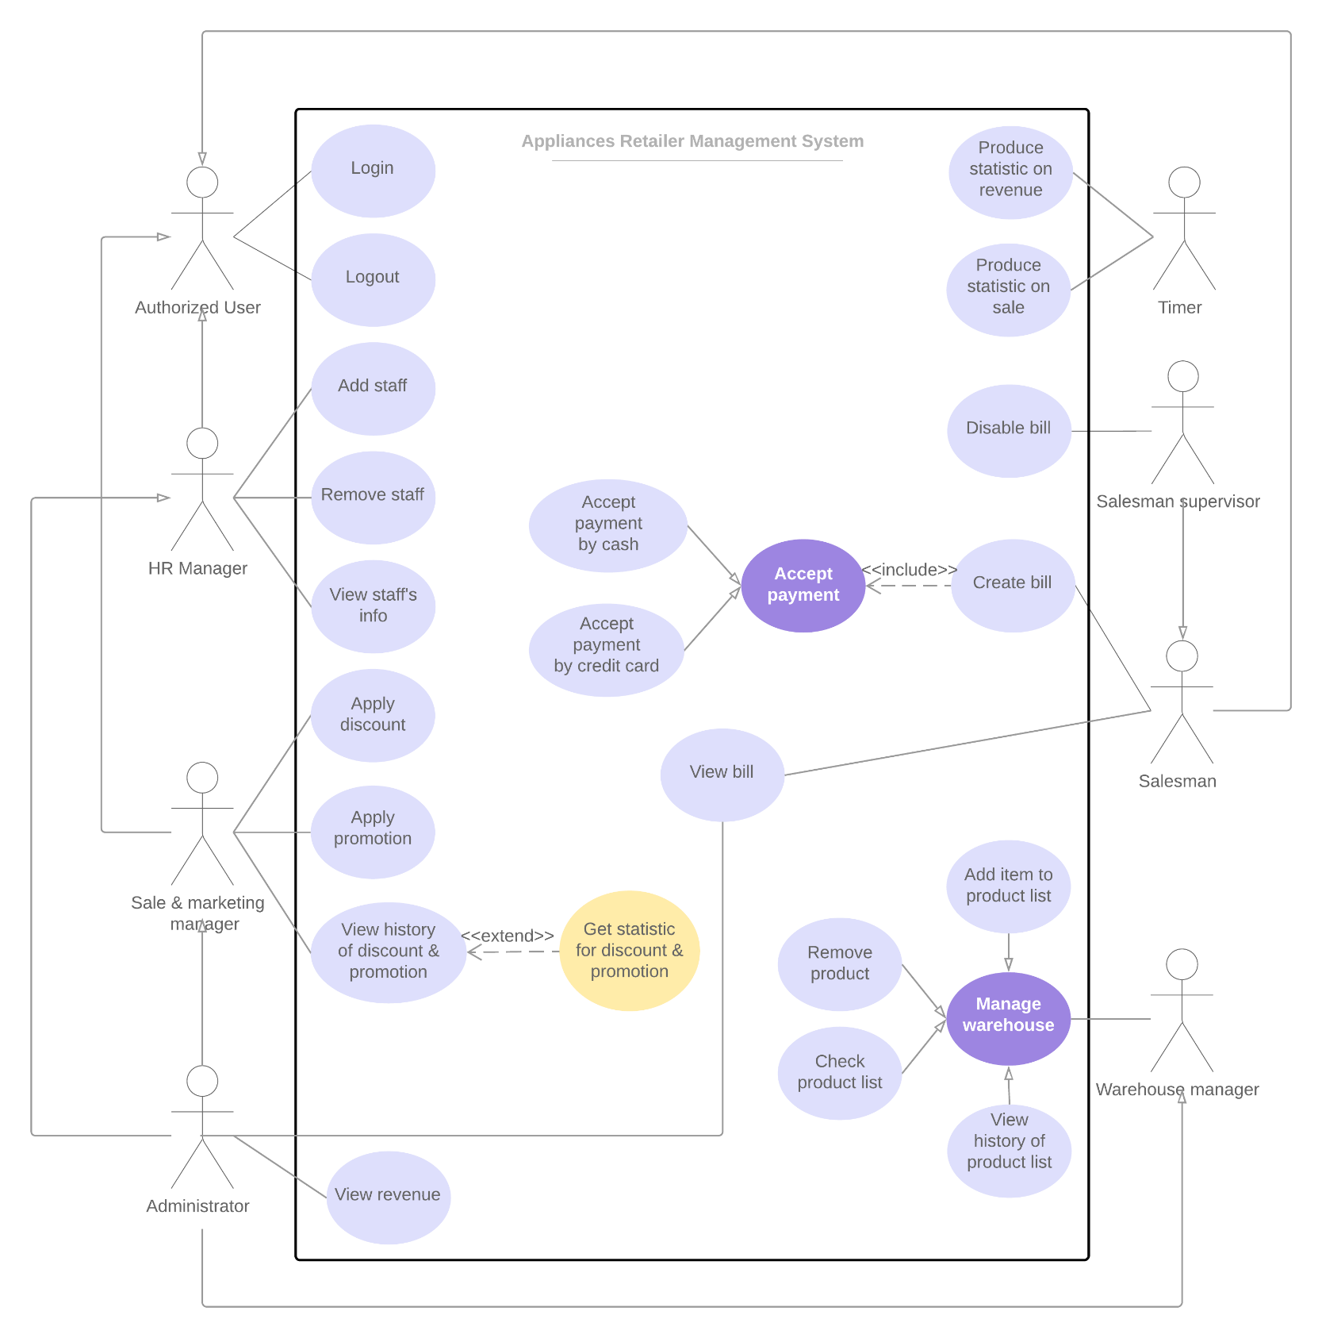Use Case Diagram

Use Case Description

UC-1. Login

|  |  |  |  |
| --- | --- | --- | --- |
| UC ID and Name: | **UC-1 Login** | | |
| Created By: | Duc Tho Tran | Date Created: | 09/10/2018 |
| Actor: | Authorized User | | |
| Trigger: | User indicates that he wants to login into system. | | |
| Description: | Users want to log on to the system with a registered role to perform their tasks and use system resources. | | |
| Preconditions: | PRE-1. The account has been initialized. | | |
| Postconditions: | POST-1. The user logged into the system corresponding to their role. | | |
| Normal Flow: | 1. User opens the application. 2. System will ask user for username and password. 3. If username and password are valid, system will show the display corresponding to their role. | | |
| Alternative Flows: | 3.1. If username or password is invalid, system notifies for user. | | |
| Exceptions: | EX-1. User’s input is invalid format. | | |
| Priority: | Low | | |
| Frequency of Use: | Medium | | |
| Business Rules: | BR-1. Every staff has an account to login into system. | | |

UC-2. Logout

|  |  |  |  |
| --- | --- | --- | --- |
| UC ID and Name: | **UC-2 Logout** | | |
| Created By: | Duc Tho Tran | Date Created: | 09/10/2018 |
| Actor: | Authorized User | | |
| Trigger: | User indicates that he wants to logout of system. | | |
| Description: | The user wants to log out, not use system resources anymore. | | |
| Preconditions: | PRE-1. Authorized user logged into system. | | |
| Postconditions: | POST-1. The user successfully logs out. | | |
| Normal Flow: | 1. User clicks on the Logout button.  2. System clears their session, and then notifies on the screen logout success. | | |
| Priority: | Low | | |
| Frequency of Use: | Medium | | |
| Business Rules: | BR-1. Every staff has an account to login into system.  BR-2. Every staff must logout at the end of their shift. | | |

UC-3. Add staff

|  |  |  |  |
| --- | --- | --- | --- |
| UC ID and Name: | **UC-3 Add staff** | | |
| Created By: | Duc Tho Tran | Date Created: | 09/10/2018 |
| Actor: | HR Manager, Administrator | | |
| Trigger: | User indicates that he wants to add new staff. | | |
| Description: | User wants to declare new staffs to the system, so they can log into the system and use resources corresponding to their role. | | |
| Preconditions: | PRE-1. Authorized user logged into system as HR Manager or Administrator role. | | |
| Postconditions: | POST-1. New staff has been added. | | |
| Normal Flow: | 1. User chooses to add a new staff. 2. System displays the fields to fill in information about the new staff. 3. User inputs staff’s information. 4. User clicks on “Add” button 5. System displays notification to confirm addition. 6. If user agrees, system stores staff’s information. | | |
| Alternative Flows: | 6.1. If user does not agree, the notification disappears. | | |
| Exceptions: | EX-1. User inputs wrong format for staff’s information. | | |
| Priority: | Medium | | |
| Frequency of Use: | Low | | |
| Business Rules: | BR-1. Every staff has an account to login into system. | | |

UC-4. Remove staff

|  |  |  |  |
| --- | --- | --- | --- |
| UC ID and Name: | **UC-4 Remove staff** | | |
| Created By: | Duc Tho Tran | Date Created: | 09/10/2018 |
| Actor: | HR Manager, Administrator | | |
| Trigger: | User indicates that he wants to remove a staff. | | |
| Description: | User wants to make a staff redundant. | | |
| Preconditions: | PRE-1. Authorized user logged into system as HR Manager or Administrator role. | | |
| Postconditions: | POST-1. All of chosen staff has been removed. | | |
| Normal Flow: | 1. User chooses to remove staffs.  2. System displays all of staff grouped by their role.  3. User ticks employees who are about to be removed.  4. User clicks on “Remove” button. 5. System displays notification to confirm deletion of staffs and requires inputting the reason for remove.  6. If user agrees and fills the input, system disables all of selected staffs. | | |
| Alternative Flows: | 6.1. If user does not agree, the notification disappears. | | |
| Priority: | High | | |
| Frequency of Use: | Low | | |
| Business Rules: | BR-1. When a staff leaves the company, their account will be disabled. | | |

UC-5. View staff’s information

|  |  |  |  |
| --- | --- | --- | --- |
| UC ID and Name: | **UC-5 View staff’s information** | | |
| Created By: | Duc Tho Tran | Date Created: | 09/10/2018 |
| Actor: | HR Manager, Administrator | | |
| Trigger: | User indicates that he wants to view staff’s information. | | |
| Description: | User wants to view staffs’ information. | | |
| Preconditions: | PRE-1. Authorized user logged into system as HR manager or Administrator role. | | |
| Normal Flow: | 1. User chooses to view staff’s information. 2. The system displays a text field where user can search by staff’s name. 3. User chooses a staff from the list displayed 4. User clicks on “View” button. 5. The system display staffs’ information. | | |
| Priority: | High | | |
| Frequency of Use: | Medium | | |

UC-6. Apply discount

|  |  |  |  |
| --- | --- | --- | --- |
| UC ID and Name: | **UC-6 Apply discount** | | |
| Created By: | Hoan Thien Nguyen | Date Created: | 09/10/2018 |
| Actor: | Sale & Marketing manager, Administrator | | |
| Trigger: | User indicates that she wants to apply discount policy | | |
| Description: | User wants to apply discount on some products. | | |
| Preconditions: | PRE-1. Authorized user logged into system as Sale & Marketing manager or Administrator role. | | |
| Postconditions: | POST-1. Discount has been applied. | | |
| Normal Flow: | 1. User chooses products 2. User chooses customer type 3. User inputs discount rate 4. User chooses time interval 5. User reviews promotion policy which has just been made 6. User chooses to apply 7. The system saves the information | | |
| Alternative Flows: | 5a. User chooses to abort  5b. Return to step 1 | | |
| Priority: | High | | |
| Frequency of Use: | Medium | | |
| Business Rules: | BR-1. Amount of money to be paid will be: (1 - discount rate)* price. | | |

UC-7. Apply promotion

|  |  |  |  |
| --- | --- | --- | --- |
| UC ID and Name: | **UC-7 Apply promotion** | | |
| Created By: | Thien Hoan Nguyen | Date Created: | 09/10/2018 |
| Actor: | Sale & Marketing manager, Administrator | | |
| Trigger: | User indicates that she wants to apply promotion | | |
| Description: | User wants to apply promotion on some products. | | |
| Preconditions: | PRE-1. Authorized user logged into system as Sale & Marketing manager or Administrator role. | | |
| Postconditions: | POST-1. Promotion has been applied. | | |
| Normal Flow: | 1. User chooses products 2. User chooses customer type 3. User choose products to be given as bonus 4. User chooses time interval 5. User reviews promotion policy which has just been made 6. User chooses to apply 7. The system saves the information | | |
| Alternative Flows: | 5a. User choose to abort  5b. Return to step 1 | | |
| Priority: | High | | |
| Frequency of Use: | Medium | | |
| Business Rules: | BR-7: Products given as bonus will be 0 as long as it is bought with specific products. | | |

UC-8. View history of discount & promotion

|  |  |  |  |
| --- | --- | --- | --- |
| UC ID and Name: | **UC-8 View history of discount & promotion** | | |
| Created By: | Duc Tho Tran | Date Created: | 09/10/2018 |
| Actor: | Sale & Marketing manager, Administrator | | |
| Trigger: | User indicates that he wants to view history of discount & promotion. | | |
| Description: | User indicates that she wants to view discount & promotion history. | | |
| Preconditions: | PRE-1. Authorized user logged into system as Sale & Marketing manager or Administrator role. | | |
| Normal Flow: | 1. User chooses to view history of discount and promotion 2. User chooses which store/whole system 3. User chooses time interval 4. User clicks View button 5. System displays history of discount and promotion | | |
| Priority: | High | | |
| Frequency of Use: | Medium | | |
| Business Rules: | BR-1. Sale & Marketing manager must review their discount & promotion twice times a month. | | |

UC-9. Get statistic for discount & promotion

|  |  |  |  |
| --- | --- | --- | --- |
| UC ID and Name: | **UC-9 Get statistic for discount & promotion** | | |
| Created By: | Hoan Thien Nguyen | Date Created: | 09/10/2018 |
| Actor: | Sale & Marketing manager, Administrator | | |
| Trigger: | User indicates that he wants to get statistic for discount & promotion. | | |
| Description: | User wants to see stats with percentages to evaluate their performance. | | |
| Preconditions: | PRE-1. Authorized user logged into system as Sale & Marketing manager or Administrator role. | | |
| Normal Flow: | 1. User chooses to get statistic for discount & promotion. 2. System asks user to choose a period time. 3. User chooses a period time. 4. System calculates statistic and displays it in the form of number and chart in that period time. | | |
| Priority: | High | | |
| Frequency of Use: | Medium | | |

UC-10. Produce statistic on revenue

|  |  |  |  |
| --- | --- | --- | --- |
| UC ID and Name: | **UC-10 Produce statistic on revenue** | | |
| Created By: | Hoan Thien Nguyen | Date Created: | 09/10/2018 |
| Actor: | Timer | | |
| Description: | Each month, the system produces statistical data on revenue for all stores. The data then will be sent to the managers via email | | |
| Priority: | High | | |
| Frequency of Use: | Medium | | |

UC-11. Produce statistic on sale

|  |  |  |  |
| --- | --- | --- | --- |
| UC ID and Name: | **UC-11 Produce statistic on sale** | | |
| Created By: | Hoan Thien Nguyen | Date Created: | 09/10/2018 |
| Actor: | Timer | | |
| Description: | Each month, the system produces statistical data on sale for all stores. The data then will be sent to the managers via email | | |
| Priority: | High | | |
| Frequency of Use: | Medium | | |

UC-12. Create bill

|  |  |  |  |
| --- | --- | --- | --- |
| UC ID and Name: | **UC-12 Create bill** | | |
| Created By: | Duc Tho Tran | Date Created: | 09/10/2018 |
| Actor: | Salesman, Salesman supervisor | | |
| Trigger: | User indicates that he wants to create bill. | | |
| Description: | User wants to create bill. | | |
| Preconditions: | PRE-1. Authorized user logged into system as Salesman or Salesman supervisor role.  PRE-2: A list of products and number of each is ready | | |
| Postconditions: | POST-1. The bill is stored into database | | |
| Normal Flow: | 1. User clicks on the “Create bill” button. 2. User scans barcode of product 3. Product is filled by data from scanner, or typed by user 4. User types number of product 5. Repeat step 2-4 until all products are inputted 6. System calculates total money customer has to pay, include VAT and notifies for user. | | |
| Priority: | High | | |
| Frequency of Use: | Medium | | |
| Business Rules: | BR-1. All bills must be stored.  BR-2. The amount the customer pays for each type product is: number of product * unit price * (1 + VAT rate). | | |

UC-13. Accept payment by cash

|  |  |  |  |
| --- | --- | --- | --- |
| UC ID and Name: | **UC-13 Accept payment by cash** | | |
| Created By: | Duc Tho Tran | Date Created: | 09/10/2018 |
| Actor: | Salesman, Salesman supervisor | | |
| Trigger: | User indicates that customer wants to accept payment by cash. | | |
| Description: | Customer wants to accept payment by cash. | | |
| Preconditions: | PRE-1. Authorized user logged into system as Salesman or Salesman supervisor role. | | |
| Postconditions: | POST-1. Payment has been accepted. | | |
| Normal Flow: | 1. User chooses bill to accept payment. 2. User announces the total to customer. 3. User inputs amount of money received from user. 4. System calculates change. 5. User returns the change. 6. User prints bill. | | |
| Priority: | High | | |
| Frequency of Use: | Medium | | |
| Business Rules: | BR-1. When accepting payment by cash, staff must store number money in and out. | | |

UC-14. Accept payment by credit card

|  |  |  |  |
| --- | --- | --- | --- |
| UC ID and Name: | **UC-14 Accept payment by credit card** | | |
| Created By: | Duc Tho Tran | Date Created: | 09/10/2018 |
| Actor: | Salesman, Salesman supervisor | | |
| Trigger: | Salesman indicates that customer wants to pay by credit card. | | |
| Description: | Customer wants to accept payment by credit card. | | |
| Preconditions: | PRE-1. Authorized user logged into system as Salesman or Salesman supervisor. | | |
| Postconditions: | POST-1. Make payment successfully. | | |
| Normal Flow: | 1. User chooses bill to accept payment. 2. User announces the total to customer. 3. User chooses credit card payment for customer. 4. Request is sent to the bank to see if the card is valid and the total is accepted. 5. System displays transaction’s information. | | |
| Exceptions: | EX-1. The credit card is out of date.  EX-2. The total is not accepted. | | |
| Priority: | High | | |
| Frequency of Use: | Medium | | |

UC-15 View bill

|  |  |  |  |
| --- | --- | --- | --- |
| UC ID and Name: | **UC-15 View bill** | | |
| Created By: | Duc Tho Tran | Date Created: | 09/10/2018 |
| Actor: | Salesman, Salesman supervisor, Administrator | | |
| Trigger: | User indicates that he wants to view bill. | | |
| Description: | Users want to check the bill for erroneous information. | | |
| Preconditions: | PRE-1. Authorized user logged into system as Salesman, Salesman supervisor or Administrator role. | | |
| Normal Flow: | 1. User chooses to view bill 2. User selects datetime interval of the bills he wants to review 3. User selects a bill he wants to review 4. User clicks on “View” button 5. System displays the bill’s information | | |
| Priority: | High | | |
| Frequency of Use: | Medium | | |
| Business Rules: | BR-1. Salesman must review their bill at the end of shift. | | |

UC-16. Disable bill

|  |  |  |  |
| --- | --- | --- | --- |
| UC ID and Name: | **UC-16 Disable bill** | | |
| Created By: | Duc Tho Tran | Date Created: | 09/10/2018 |
| Actor: | Salesman supervisor | | |
| Trigger: | User indicates that he wants to disable bill. | | |
| Description: | User wants to disable the wrong information bill generated by the salesman. | | |
| Preconditions: | PRE-1. Authorized user logged into system as Salesman supervisor role. | | |
| Postconditions: | POST-1. The bill has been cancelled. | | |
| Normal Flow: | 1. Salesman supervisor clicks on the button disable bill. 2. Salesman supervisor enters bill code. 3. System disables the bill and notifies on the screen. | | |
| Exceptions: | EX-1. Salesman supervisor inputs wrong bill code. | | |
| Priority: | High | | |
| Frequency of Use: | Low | | |
| Business Rules: | BR-1. When the salesman enters the wrong value into the bill, it must be disabled. | | |

UC-17. Add item to product list

|  |  |  |  |
| --- | --- | --- | --- |
| UC ID and Name: | **UC-17 Add item to product list** | | |
| Created By: | Duc Tho Tran | Date Created: | 09/10/2018 |
| Actor: | Warehouse manager, Administrator | | |
| Trigger: | User indicates that he wants to add item to product list. | | |
| Description: | User wants to add products to the list of products available in the warehouse. | | |
| Preconditions: | PRE-1. Authorized user logged into system as Warehouse manager or Administrator role. | | |
| Postconditions: | POST-1. The item has been added. | | |
| Normal Flow: | 1. User asks to add item to product list. 2. System displays interface to add item. 3. User inputs product id, name, quantity and product description. 4. User confirms his/her desire. 5. System notifies action success. | | |
| Exceptions: | EX-1. User inputs wrong format. | | |
| Priority: | Medium | | |
| Frequency of Use: | High | | |
| Business Rules: | BR-1. When products are warehoused, items and quantities should be recorded by warehouse manager. | | |

UC-18. Remove item to product list

|  |  |  |  |
| --- | --- | --- | --- |
| UC ID and Name: | **UC-18 Remove item to product list** | | |
| Created By: | Duc Tho Tran | Date Created: | 09/10/2018 |
| Actor: | Warehouse manager, Administrator | | |
| Trigger: | User indicates that he wants to remove product list. | | |
| Description: | When exporting from the warehouse, the warehouse manager wants to record the information on the system. | | |
| Preconditions: | PRE-1. Authorized user logged into system as Warehouse manager or Administrator role. | | |
| Postconditions: | POST-1. The product list is updated | | |
| Normal Flow: | 1. User asks to remove product from list. 2. System displays product list to remove. 3. User chooses which products to remove. 4. User inputs remove description. 5. User confirms his desire. 6. System notifies action success. | | |
| Priority: | Medium | | |
| Frequency of Use: | Medium | | |
| Business Rules: | BR-1. When exporting products, information must be imported in the system. | | |

UC-19. Check product list

|  |  |  |  |
| --- | --- | --- | --- |
| UC ID and Name: | **UC-19 Check product list** | | |
| Created By: | Duc Tho Tran | Date Created: | 09/10/2018 |
| Actor: | Warehouse manager, Administrator | | |
| Trigger: | User indicates that he wants to review his product list. | | |
| Description: | User wants to review his product list instantly. | | |
| Preconditions: | PRE-1. Authorized user logged into system as Warehouse manager or Administrator role. | | |
| Normal Flow: | 1. User asks to check product list. 2. The system displays all the products left in the warehouse. | | |
| Priority: | Medium | | |
| Frequency of Use: | Medium | | |
| Business Rules: | BR-1. Warehouse manager must check inventory at the end of the day. | | |

UC-20. View history of product list

|  |  |  |  |
| --- | --- | --- | --- |
| UC ID and Name: | **UC-20 View history of product list** | | |
| Created By: | Duc Tho Tran | Date Created: | 09/10/2018 |
| Actor: | Warehouse manager, Administrator | | |
| Trigger: | User indicates that he wants to review history of product list. | | |
| Description: | User wants to review history of product list instantly. | | |
| Preconditions: | PRE-1. Authorized user logged into system as Warehouse manager or Administrator role. | | |
| Normal Flow: | 1. User asks to review products’ history. 2. The system requires user to choose a period of time to review product list’s history. 3. System displays all import or export history of the repository in that period of time. | | |
| Priority: | Medium | | |
| Frequency of Use: | Low | | |
| Business Rules: | BR-1. Warehouse manager must review the history of product list twice times a week. | | |

UC-21. View revenue

|  |  |  |  |
| --- | --- | --- | --- |
| UC ID and Name: | **UC-21 View revenue** | | |
| Created By: | Hoan Thien Nguyen | Date Created: | 09/10/2018 |
| Actor: | Administrator | | |
| Trigger: | Administrator indicates that he wants to view revenue | | |
| Description: | Administrator would like to review the revenue immediately to assess the financial situation. | | |
| Preconditions: | PRE-1. Authorized user logged into system as Administrator role. | | |
| Normal Flow: | 1. Admin chooses to view revenue.  2. Admin chooses which store/whole system.  3. Admin chooses time interval.  4. Admin clicks “View” button.  5. System displays revenue. | | |
| Alternative Flows: | None | | |
| Priority: | High | | |
| Frequency of Use: | High | | |